***International figure skating competition for single skaters***

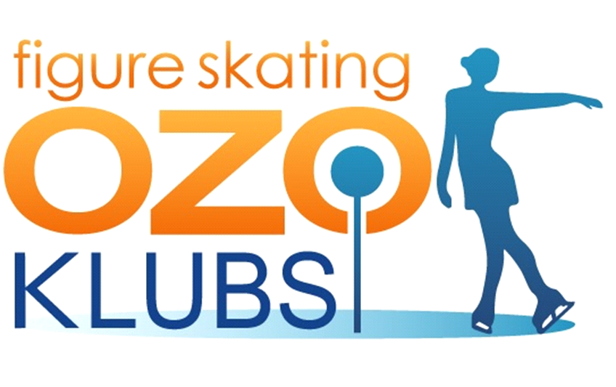

**OZO AUTUMN CUP 2024**

**EVENT TIME: October 19.-20. 2024**

**ORGANIZER: OZO Figure skating club**

**VENUE OF COMPETITION: MARUPE Ice Hall,**

**Marupe, Kantora street 128**

**Latvia**

***ANNOUNCEMENT***

**GENERAL:**

The “OZO Autumn Cup 2024” will be conducted in accordance with the ISU Constitution and General Regulations, the ISU Special Regulations for Figure Skating as well as all pertinent ISU Communications for Figure Skating and the classification of the Latvian Skating Union for season 2024

**ORGANIZER:**

Figure skating club “OZO”

E-mail: [ieva.pujate@gmail.com](mailto:ieva.pujate@gmail.com)

Phone number: +371 29490345

**DATE:**

19.10.2024 – 20.10.2024

**PLACE OF COMPETITION:**

Latvia, Marupe, Kantora iela 128, “MARUPE ice rink”

(an indoor ice-rink with ice surface of 28 x 56 m, air-conditioned and heated)

**ENTRIES OF COMPETITIONS:**

All the members of ISU and Clubs, being members of National Skating Federations associated with ISU, are invited to take part in this competition Members can enter any quantity of Skaters into each category.

Organizers have the right to refuse or limit the participation in competition. The attached entry forms have to be filled in precisely and can be sent by e-mail on the address given below by October 7. 2024 to:

E-mail [ieva.pujate@gmail.com](mailto:ieva.pujate@gmail.com)

\

The deadline for entries is  **October 7 2024**

**CATEGORIES:**

Senior Men and Women

According to the latest ISU regulations and communications

Junior Men and Women

According to the latest ISU regulations and communications

*Interclub: Boys and Girls* : Advanced Novice, Basic Novice, Intermediate Novice,

*Youngsters Boys and Girls*: Chicks A, Chicks Axel, Pre-Chicks A

*And Men, Women/Boys , Girls* : Senior B, Junior B, Novice B, Springs B, Cubs B, Chicks B, Pre-Chicks B, Chicks C, Pre-Chicks C, Beginners and Elements A,B ,according to technical data

**ENTRY FEE:**

Single Skating with 2 programs – 90 Eur

Single Skating 1 ( one) program - 75 Eur

Elements – 45 Eur

**EXPENSES:**

**Judges, Referees and Technical Panel**

The Organizer will provide accommodation and meals for all Referees, Judges drawn for the panel, Technical Controllers, Technical Specialists, Data and Replay Operators.

**Competitors** Competitors and all other Team Members are responsible for their own travel, accommodation and meal expenses.

**LIABILITY:**

In accordance with Rule 119, it is the sole responsibility of each Member participating in the competition, to provide medical and accident insurance for their athletes, officials and all other members of the Member’s team. Such insurance must assure full medical attendance and also the return to the home country by air transport or by other expeditious means of the ill or injured person.

The Organizer assumes no responsibility for or liability with respect to bodily or personal injury or property damage incurred in connection with the event mentioned above.

**THE CODE OF ETHICS:** All the skaters, coaches, judges, chaperons should follow the ISU Communication 2641 (or any update of this Communication). Action against this rule conducts by itself the disqualification of the skater.

**MUSIC:**

All competitors shall furnish competition music of excellent quality on flash format or send to e-mail [info@palmaaudio.lv](mailto:info@palmaaudio.lv)

Music must have Competitor `s name, Member`s name and the exact running time of the Music (not skating time) including any starting signal and must be submitted at the time of registration.

**RESULTS:** Judging and calculations will be done according to ISU Special Regulations and

Technical Rules Single & Pair Skating and Ice Dance 2018

Result information and detailed protocols will be available on the website: [www.ozoklubs.lv](http://www.ozoklubs.lv)

**AWARDS:**

The top three competitors in each event (Final results) will be honored and awarded by Trophies, special presents and diplomas; otherswill receive memory presents. The exact time of the Awarding ceremonies will be announced in the detailed schedule in due time. Please make sure that all skaters are represented at the Ceremony.

**DRAWING:**

Draw will be done electronically and Starting orders will be available at the webpage [www.ozoklubs.lv](http://www.ozoklubs.lv)

There will be no draw for the free skating, Advanced Novices, Junior, Senior .The start list will be in opposite order.

**TIMETABLE:**

Detailed time schedule will be sent to all members soon after the close of entries and will be published at the webpage [www.ozoklubs.lv](http://www.ozoklubs.lv)